General information about the crops
BER
Season – Rabi Crop
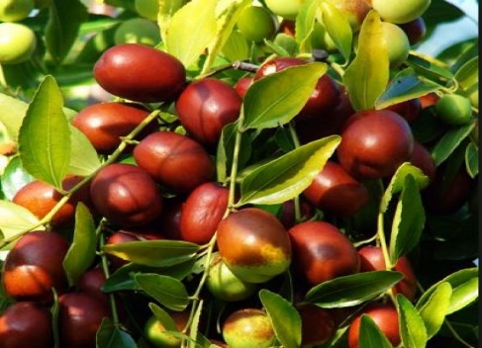
General
- It is an ancient fruit of India and China .
- It has a wide adaptability because of which it is cultivated all over the India especially the drier parts of Indian sub – Continent .
- It is often called poor man’s fruit .

- Climate
Temp  (15°C/40°C) | Rainfall  (300 MM/400MM)
Sowing Temperature  (15 - 37°C) | Harvesting Temperature  (30- 40°C)

- Popular variety with their Yield.
Variety | Yield
Umran | 150 -200 kg
Sanaur – 2 | 150kg
Wallaiti | 114 kg
Kaithli | 120 kg
Z G - 2 | 150 kg
Gola | 80 kg
Dandan | 94 kg

- Land preparation

- Generally no cultivation is practiced in the Ber Orchard .
- It propagate vegetative through Rhizomes / Bulbs .
- Ploughing is required at the time of manuring and in September – October .

- Sowing
- Transplanting is carried out in February – March po August – September.
- Defoliate the plant while lifting from nursery for transplantation purpose and the spacing is required – 7.5×7.5 m.

- Seed Rate
- For early variety – 100 kg/ha
- For late variety – 125/ha

- Seed Treatment
- Seed soaking in concentrated sulphuric acid for 6 minutes gave higher seed germination.

- Fertilizer Requirement
Crop | Well Decomposed Cow Dung (kg) | Urea (in gram)
First year | 20 | 200
Second year | 40 | 400
Third year | 60 | 600
Fourth year | 80 | 800
Fifth year | 100 | 1000

- Fertlizer Application

- Apply 20kg/tree Well decomposed Cowdung for 1 year old crop along with Urea@200gm/tree.
- Increased dose of Cowdung by 20 kg and Urea by 200 gm for 2 years old crop i.e Cowdung@40kg and urea@400gm.
- Apply whole Cowdung in may month
- Apply Urea in 2 equal parts , First dose should be givne in juLY – August and second phase dose is applied at after fruit set.

- Weed Control

- Manual Weeding
- Pre – emergence application of Hexuron 80 WP(diuron) at 3 kg/ha during first fortnight of August.
- Glycel 41 SL (glyphosphate )at 3 litres /ha .
- Post – emergence application of gramoxone 24WSC (paraquat) at 3 lites /ha.

- Irrigation

- Irrigation is essential during the development of fruit i.e from October to February at an internal of 3 to 4 weeks .
- It Require Irrigation in the second half of September and in October

- Plant Protection
Fruit Fly – serious pest of Ber .
Management
Spray of Dimeethoate@500ml/300ltr of Water in February – march .

Leaf Eating Caterpillar – They feed on leaves and tender fruits and thus affect fruit quality .
Management
Spray Carbaryl 2750/250LTR OF Water .

Disease Control
Powdery Mildew
Spray of wet table sulphur@250gm/100ltr of water during Flowering stage.
Leaf Mould
Spray of Copper Oxychloridew@300gm in 100 ltr in water .

- Harvesting

- The beer tree grows quickly and the first crop can be harvested within 2 – 3 years of Planting .
- The fruit itself requires about 22- 26 weeks to mature after fruit – setting .
- In North India , harvesting done at the time in mid – March to mid – April .
- In south India , the fruit is harvested in October to November .
- Harvesting should be done when it acquire normal size and color e.g golden color.

- Storage
Ber fruits are usually stored at ambient/room temperature (25–35°C) from harvest until their consumption. Jawanda et al. [82] observed that Umran and Sanaur-2 fruits could be stored for up to 10–12 days at room temperature.

